**Fix-it game template**

Modulette ID:

Game #:

Game title: Fix-it

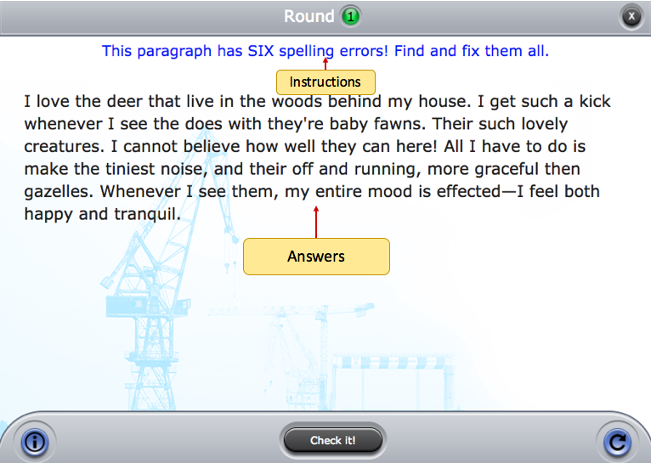

**Instructions:** (Use if instructions are the same for every round)

Round #

**Instructions:** (Use if the instructions are round specific)

**Prompt:** (Rarely used in this game, but is available. Can be text or image.)

**Correct feedback:** (Message to display when answered correctly)

**General incorrect Feedback:** (Message to display when answered incorrectly)

**Answers:** See example below. Words to be fixed should look like this: [displayed word|correct answer]. Sometimes there will be more than one correct fix. You can make a word that doesn’t need a correction selectable by putting it in brackets. Overwrite the example with the answer for the round.

|  |
| --- |
| I love the [deer] that live in the woods behind my house. I get such a kick whenever I see the does with [they're|their] baby fawns. [Their|They're|They are] such lovely [creatures]. I cannot believe how well they can [here|hear]! All I have to do is make the tiniest noise, and [their|they are|they're] off and running, more graceful [then|than] gazelles. Whenever I see them, my entire mood is [effected|affected]—I feel both happy and tranquil. |